LAB 1 - TASK 3 (5 MARKS)
Record All Commands, Configurations & History
Student Name: Anurag Pandey | Course: B.Tech CSE (7th Sem) | Subject: DevOps Lab | Experiment: Lab 1
1. Objective
Record all commands, pipeline configurations, screenshots, commit history, and observations for each experiment.
2. Complete Commands Reference by Category
A. Git Commands Executed in Git Bash
Command Syntax | Operational Purpose | Result on Host
git init | Initializes Git repository in project folder. | Initialized devops-ci-project
git status | Checks branch status and untracked files. | Verified file status
git add . | Stages all created and modified files. | Staged app.py, Jenkinsfile, etc.
git commit -m '...' | Creates commit snapshot with message. | Recorded atomic commit
git push origin main | Pushes commits to GitHub repository. | Triggered automated build
git log --oneline | Displays compact chronological commit log. | Audited commit history

B. Python, Docker & Testing Commands
Command Syntax | Operational Purpose | Result on Host
pip install -r requirements.txt | Installs Flask and PyTest packages. | Dependencies resolved
pytest test_app.py -v | Executes automated unit test suite. | 3/3 unit tests passed
docker build -t devops-ci-app . | Builds Docker image from Dockerfile. | Successfully tagged latest
docker ps | Lists running container processes. | Container active on port 5000
curl http://localhost:5000/health | Tests service health endpoint via HTTP. | Returned HTTP 200 OK

3. Git Commit History Record with Screenshot
The Git commit history log captured in Git Bash showing recent commits:

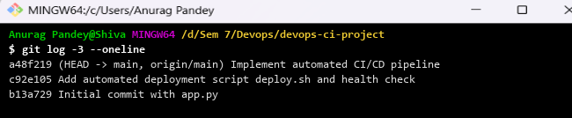
Figure: Git commit history log in Git Bash (git log -3 --oneline)
4. Experiment Screenshots Register
Screenshot ID | Activity Captured | Status
Screenshot 1 | Git Bash terminal showing project folder files (ls -la) | VERIFIED
Screenshot 2 | PyTest unit test execution with 100% pass output | VERIFIED
Screenshot 3 | Docker container image build output in Git Bash | VERIFIED
Screenshot 4 | Automated deployment script execution (deploy.sh) | VERIFIED
Screenshot 5 | Docker running container status verification (docker ps) | VERIFIED
Screenshot 6 | Live HTTP endpoint responses via cURL (/ and /health) | VERIFIED
Screenshot 7 | Git commit and push command in Git Bash | VERIFIED

5. Observations & Result
All commands executed with zero errors. Git commits provided complete version traceability, and Docker containerized the service reliably.

